From Pencil Lines to People’s Lives
Jeremy Mead
  - A relaxed story of 62 years in building, design, and helping people through difficult projects
I did not plan a 62-year career in building; I just started with a pencil, a bungalow, and no idea how far it would take me.
My working life in building started when I was 14, with the design and conversion of a bungalow into a house for a client not a relative. I was young enough to be learning nearly everything the hard way, but old enough to know I liked drawing things, working things out, and seeing an idea turn into bricks, timber, and something real.
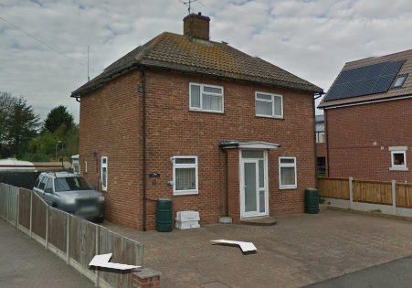
Things were a bit simpler then. Once planning was approved, the building inspector asked for two copies of the plans with construction details, so I drew three complete copies by hand: two for the inspector and one for the builder. I had not discovered tracing paper or reproduction copies, so it was all done the long way round, line by line. It was not an architectural masterpiece, but according to Google it is still standing 62 years later, and you can still see the join. Soon after that, at 15, I left home.
That first job probably says a lot about the rest of my career. I learned as I went, solved problems as they appeared, and stayed close to the practical side of construction. I have always liked the moment when a drawing stops being just lines on paper and starts becoming something people can walk into, use, and live with.
After that I spent around 15 years in college and workplace training, collecting diplomas and certificates along the way. University was not really the normal route into this sort of work then, so most of what mattered was learned through study, practice, and being willing to get stuck in. Some of the best lessons came from older hands who could look over a drawing, spot the bit that would never work on site, and send me back to think again.
From there I worked in architectural and construction practices across the United Kingdom and overseas. One chapter involved American-led work, and another took me to one of the world’s largest architectural practices, where I worked as senior construction designer on a project to design a new town on an island in the Caribbean. It was hard work, but someone had to do it. The setting could hardly have been more different from that first bungalow, but the job still came down to the same basics: make the drawings work, understand how the building will be built, and keep asking the practical questions.
The work has always been varied. Some projects were large and international, while others were much closer to home, including residential extensions in Wales. I have always thought the smaller local jobs matter just as much, because they are the ones people live with every day.
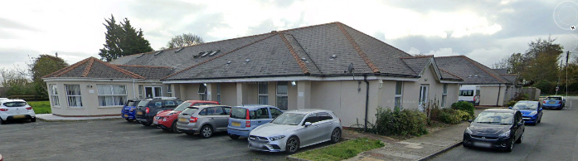
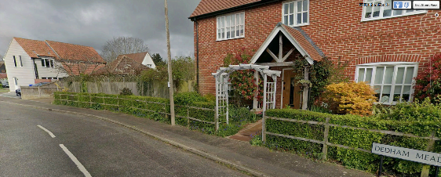
Over the years, as a senior partner and director, I have designed and supervised housing estates in Constable Country around Dedham, through to South Wales and Scotland; more than 90 nursing homes around the country; a hospital on the island of Ireland; commercial property projects around the world; factories; and shopping centres. I also spent time in commercial facilities, including as Vice President Europe for facilities (American for Factories) for an American multinational, which gave me wide experience of operational buildings, factory environments, and the practical problems that come with keeping complex places working properly.
After Covid, I began stepping back from major contracts. For health reasons I had spent much of that time locked up in a bungalow, which felt rather ironic given where my working life had started. Our major PLC client was a nursing home provider, and that sector was hit terribly hard by Covid. In the end, we decided as a practice that it was time to stop doing that kind of work.
Even so, I found I could not simply walk away from people who still needed help. Some were existing clients trying to get through difficult situations with builders, authorities, or inspections. Others came later, often because they had a site with problems and no one else seemed willing to step in. I have helped where I can and if I can.
That is where the idea of a building forensic consultancy began. The aim is to help people caught in the nightmare of a building project gone wrong. Some still have the money and strength to keep fighting, and they can be charged properly for professional help. Others have nothing left: no money, no confidence, no drive, and no one standing beside them. My hope is to use the paid work, profits, and my own time to help those people too.
Looking back, I have learned that buildings are never just buildings; they are people’s homes, savings, health, and peace of mind. After 62 years, the most useful thing I can still do is turn up, look properly, explain things plainly, and help people find a way through.
As part of that work, I have also gained a further qualification at the age of 76, becoming an Expert Witness able to prepare and present reports for the courts of the UK.
If you or someone you know
is facing a building problem that feels worrying, confusing, or unfair, do not wait until it becomes even harder to resolve. Whether it involves a dispute with a builder, poor workmanship, inspection problems, unfinished work, planning or building regulations, or simply not knowing what to do next, please get in touch. I can look at the situation clearly, explain what is happening in plain English, and help you decide the most practical way forward. If the charity is able to help, you do not need to worry about the cost of asking for help; the important thing is to make contact and let someone look at the problem properly.
Sometimes the first conversation is enough to make the problem feel a little less lonely.

